AN INTERNSHIP PROJECT REPORT
On
Front End Web Development
Submitted in partial fulfilment of the requirements for the award of the degree
BACHELOR OF TECHNOLOGY
in
COMPUTER SCIENCE AND ENGINEERING
Submitted by
T.N.S.SAI VARDHAN
(22026A0521)


DEPARTMENT OF COMPUTER SCIENCE AND
ENGINEERING UNIVERSITY COLLEGE OF ENGINEERING KAKINADA
Jawaharlal Nehru Technological University Kakinada Kakinada-533003, Andhra Pradesh, INDIA DEPARTMENT OF COMPUTER SCIENCE AND
ENGINEERING UNIVERSITY COLLEGE OF ENGINEERING KAKINADA
Jawaharlal Nehru Technological University Kakinada

Kakinada-533003, Andhra Pradesh, INDIA


CERTIFICATE
This is to certify that this project report entitled “FRONT END WEB
DEVELOPMENT” is a bonafide record of the work being submitted by T.N.S.SAI VARDHAN bearing the roll number 22026A0521, in the partial fulfilment of the requirements for the award of the degree of
Bachelor of Technology in COMPUTER SCIENCE AND ENGINEERING to the UCEK, JNTUK, Kakinada, Andhra Pradesh, India. It has been found satisfactory and hereby found satisfactory and hereby approved for submission.

Signature of Head of the Department
Dr. N. Ramakrishnaiah
Professor & HOD
Department of CSE
UCEK , JNTU KAKINADA

Summer Internship Report

Submitted by the requirement for the degree of Bachelor of Technology

Name of the College : University College of Engineering, Kakinada

Department : Computer Science and Engineering

Duration of the Internship : 8 weeks

Name of the Student : Thummalappalli N S Sai Vardhan

Programme of Study : B.Tech

Year of Study : III Year II Semester

Register Number : 22026A0521

Date of Submission : 18th January 2025

STUDENT’S DECLARATION

I, THUMMALAPALLI N S SAI VARDHAN, a student of the B.Tech Program, Regd. No. 22026A0521, of the Department of Computer Science and Engineering, University College of Engineering Kakinada, do hereby declare that I have completed the mandatory Summer Internship from May 2024 to July 2024 from DevSkillHub.

(Student Signature and Date)

ACKNOWLEDGEMENT
I would like to express my sincere gratitude to DevSkillHub for providing me with the opportunity to work as a Front End Web Development intern. I am grateful to have been selected for the internship through the APSCHE Portal, which has significantly contributed to my academic and professional growth.

I would like to extend my special thanks to my mentor and the entire team at DevSkillHub for their constant support, guidance, and encouragement throughout the duration of my internship. Their expertise in the field Front End Web development helped me develop a deeper understanding of the concepts and provided me with invaluable hands-on experience.

I also wish to thank my Teachers at University College of Engineering, Kakinada for their continuous support and for creating a conducive learning environment. This internship has greatly enhanced my skills and knowledge. I would like to express my heartfelt thanks to APSCHE for giving us the beautiful opportunity to do this project. I would like to acknowledge that this project was completed entirely by me and not by someone else.

THUMMALAPALLI N S SAI VARDHAN
22026A0521

PROJECT INTERNSHIP COMPLETION CERTIFICATE

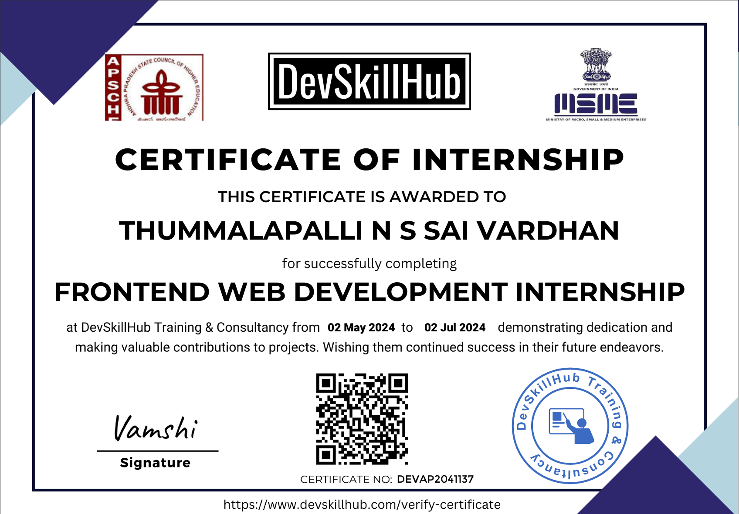

ABSTRACT
This report details the experiences and learning outcomes from a front-end web development internship, focusing on the technical and professional aspects of the role. The internship involved working extensively with technologies like HTML, CSS, JavaScript, and React to design and implement responsive and interactive user interfaces. Through these tasks, the internship provided hands-on exposure to industry-standard tools such as Git for version control and Figma for design collaboration.

In addition to technical skills, the internship emphasized the importance of teamwork, communication, and time management in a professional setting. Challenges like debugging complex issues and balancing quality with tight deadlines offered valuable problemsolving opportunities. Overall, the experience served as a comprehensive introduction to the modern web development process, equipping the intern with both the technical expertise and soft skills necessary for success in the field.

TABLE OF CONTENTS
CHAPTER 1- DESCRIPTION OF THE INTERNSHIP
CHAPTER 2- OVERVIEW OF THE INTERNSHIP
CHAPTER 3- INTRODUCTION OF PROJECT
CHAPTER 4- PROJECT IMPLEMENATION
CHAPTER 5- HTML
CHAPTER 6- CSS
CHAPTER 7- JAVASCRIPT
CHAPTER 8- OUTPUT OF THE PROJECT

CHAPTER 1

DESCRIPTION OF THE INTERNSHIP
Role Summary:
We are seeking a motivated and creative Front-End Development Intern to join our team. As an intern, you will work closely with designers, developers, and other stakeholders to create visually appealing and highly functional user interfaces. This role is ideal for someone passionate about web technologies and eager to contribute to innovative digital solutions.

Key Responsibilities:
- Collaborate with cross-functional teams, including UI/UX designers, backend developers, and product managers, to implement front-end features.
- Develop and maintain responsive, mobile-friendly web applications using HTML, CSS, and JavaScript.
- Optimize application performance for maximum speed and scalability.
- Debug and troubleshoot layout and scripting issues in existing web pages and applications.
- Utilize front-end frameworks like React, Angular, or Vue.js to build dynamic and interactive user experiences.
- Implement accessibility standards to ensure web applications are inclusive for all users.
- Test applications across various devices and browsers to ensure consistent functionality and visual presentation.
- Participate in team meetings, provide input on design and functionality, and stay engaged with the overall project goals.
- Assist with documentation of workflows, processes, and code for future reference and scalability.

Requirements:
- Strong foundational knowledge of HTML5, CSS3, and JavaScript.
- Familiarity with CSS preprocessors (e.g., Sass, LESS) and modern CSS frameworks like Bootstrap or Tailwind CSS.
- Basic experience with front-end libraries/frameworks (e.g., React, Angular, or Vue.js).
- Understanding of version control systems (e.g., Git/GitHub) for collaborative development.
- Awareness of web performance optimization techniques and SEO best practices.
- Knowledge of design tools such as Figma, Sketch, or Adobe XD is a plus.
- Awareness of RESTful APIs and basic integration concepts.
- Passion for user-centric design, accessibility, and delivering seamless user experiences.
- Ability to work in a fast-paced environment, manage time effectively, and adapt to new challenges.

What You’ll Gain:
- Real-world experience in developing modern web applications and working with cutting-edge technologies.
- Mentorship from industry experts to enhance your technical and soft skills.
- Exposure to agile development methodologies and collaborative teamwork.
- An opportunity to contribute to impactful projects that may go live during the internship.
- A portfolio of real-world projects to showcase to future employers.
- Networking opportunities and connections with professionals in the tech industry.
- Letter of recommendation and a potential pathway to a full-time position upon successful completion of the internship.

Duration & Location:
- Internship Duration: 8 weeks
- Mode: Online
- Location: From home
- Stipend: None

CHAPTER 2

OVERVIEW OF THE INTERNSHIP
DevSkillHub is an APSCH-approved platform offering premium online courses and internships. Focused on delivering top-notch education, the platform provides industryexpert-led courses across diverse fields. It bridges theoretical knowledge with practical experience, ensuring students gain the skills needed for career success in technology, business, arts, and more.

Objective:
To develop a front-end web interface that:
- Simplifies student registration and profile management.
- Provides real-time access to academic records, timetables, and exam schedules.
- Facilitates seamless communication between students, faculty, and administrative staff.
- Offers an intuitive and mobile-friendly user interface to enhance accessibility.

Learning Outcomes:
- Understanding the principles of responsive web design and accessibility.
- Gaining hands-on experience with modern front-end frameworks.
- Implementing real-world workflows for academic management systems.
- Debugging and optimizing front-end performance for scalable applications.

CHAPTER 3

INTRODUCTION OF PROJECT RANDOM PASSWORD GENERATOR
The Random Password Generator project is a simple yet highly functional front-end web application designed to create secure and customizable passwords. With the increasing emphasis on cybersecurity, this project addresses the need for strong, unpredictable passwords to protect sensitive accounts and data.
This application allows users to generate passwords based on specific criteria, such as length, inclusion of uppercase and lowercase letters, numbers, and special characters. Built using fundamental web development technologies, the project showcases the practical implementation of HTML, CSS, and JavaScript to create a responsive and interactive user interface.
Purpose:
The primary purpose of this project is to help users create strong and reliable passwords that meet security standards, ensuring protection against unauthorized access and potential cyber threats.
Key Features:
- Customizable Password Settings:
  - Set the desired password length.
  - Choose specific character types (letters, numbers, symbols).
- Randomized Algorithm:
  - Generates passwords using a randomized selection process for maximum unpredictability.
- Copy to Clipboard:
  - A convenient "Copy" button to easily transfer the generated password.
- Responsive Design:
  - Accessible and user-friendly across desktops, tablets, and mobile devices.
Technologies Used:
- HTML5: To structure the web page elements.
- CSS3: For styling and making the application visually appealing and responsive.
- JavaScript: To implement the password generation logic and interactivity.
Learning Outcomes:
- Gaining a deeper understanding of randomization techniques in JavaScript.
- Learning how to manipulate the DOM (Document Object Model) for realtime user interactions.
- Understanding responsive design principles to make the application adaptable to various devices.
- Applying best practices for structuring code and enhancing user experience.

CHAPTER 4

PROJECT IMPLEMENTATION
Step 1: Structure the Web Page (HTML)
The first step is to create the layout of the password generator.
- Title and Header:
  - Add a heading to indicate the purpose of the application (e.g., "Random Password Generator").
- Password Display Section:
  - A text input field to display the generated password. o A "Copy" button to allow users to copy the password to the clipboard.
- Controls for Customization:
  - A numeric input to allow the user to specify the password length. o Checkbox inputs for selecting different character types: uppercase letters, lowercase letters, numbers, and symbols.
- Generate Button:
  - A button to trigger the password generation function.
This step ensures the user has a clear interface for interacting with the generator.

Step 2: Styling the Web Page (CSS)
The second step is to make the interface visually appealing and user-friendly.
- Layout Design:
  - Center the content on the page using flexbox for a clean and modern appearance.
- Password Display:
  - Style the password input field to make it readable and visually appealing.
  - Style the "Copy" button with contrasting colors to draw attention.
- Controls and Labels:
  - Use spacing and alignment to group related controls (like checkboxes) neatly.
  - Ensure labels are clearly associated with their respective inputs.
- Responsive Design:
  - Use CSS to ensure the layout adjusts well on different devices, such as mobile phones and tablets.

Step 3: Adding Functionality with JavaScript The core logic is implemented in JavaScript.
- Character Sets Definition:
  - Define the available character sets as strings for each type:
    - Uppercase letters (A-Z) o Lowercase letters (a-z) o Numbers (0-9) o Symbols (e.g., !@#$%^&*)
- User Input Handling:
  - Retrieve user inputs for:
    - Password length (from the numeric input).
    - Selected character types (checked/unchecked checkboxes).
- Pool Creation:
  - Combine the selected character sets into a single "pool" of characters.
For example: o If the user selects uppercase and numbers, the pool will be "ABCDEFGHIJKLMNOPQRSTUVWXYZ0123456789".
- Random Password Generation:
  - Use a loop to randomly select characters from the pool:
    - The Math.random() function generates a random number between 0 and 1. o Multiply the random number by the length of the character pool to get a valid index.
    - Use Math.floor() to round down to an integer index.
    - Append the randomly chosen character to the password string.
- Display the Password:
  - Once the password is generated, display it in the text input field.
- Copy to Clipboard:
  - Use JavaScript’s clipboard API to copy the generated password when the "Copy" button is clicked:
    - Select the password text programmatically.
    - Execute the document.execCommand('copy') function to copy it to the clipboard.

Step 4: Enhancing User Experience
1. Error Handling:
    - Ensure at least one character type is selected before generating the password. If not, alert the user.
    - Validate the password length input (e.g., minimum of 4 and maximum of 32).
2. Interactive Feedback:
    - Add an alert or notification when the password is successfully copied to the clipboard.
3. Default Values:
    - Pre-fill default settings for length and character types to simplify the user experience.

Step 5: Testing and Debugging
1. Functionality Testing:
    - Test the application by generating passwords of various lengths and configurations to ensure correctness.
2. Cross-Browser Compatibility:
    - Verify the application works seamlessly on different browsers (Chrome, Firefox, Edge, etc.).
3. Responsive Behavior:
    - Check the layout on devices with varying screen sizes.

Step 6: Deployment
1. Code Optimization:
    - Clean up redundant code, use comments for clarity, and ensure the code is well-structured.
2. Host the Application:
    - Use a platform like GitHub Pages, Netlify, or Vercel to host the project and make it accessible online.
3. Share the Application:
    - Share the link for others to test and use.

Extensions and Improvements
1. Password Strength Indicator:
    - Add a visual indicator to show the strength of the generated password.
  - Save Passwords: o Provide an option to save generated passwords locally.
  - Theme Customization:
    - Allow users to switch between light and dark themes.
4. Integration: o Integrate the tool into a broader security suite or application.

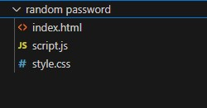

CHAPTER 5

HTML DESCRIPTON AND SOURCE CODE
Purpose of the HTML
The primary goal of the HTML in this project is to create a simple, accessible, and functional layout that allows users to interact with the password generator. It defines:
- Input fields for user customization (e.g., password length and character preferences).
- Buttons for generating and copying passwords.
- A section to display the generated password.
Key HTML Elements
- Title and Heading
  - <title>: Defines the title of the web page as displayed in the browser tab.
  - <h1>: Displays the main heading, such as "Random Password Generator," to indicate the purpose of the application.
- Password Display Section
  - <input type="text">: A read-only text field to show the generated password.
  - <button>: A button labeled "Copy" for copying the password to the clipboard.
- Controls for Customization
  - Password Length Input:
    - <input type="number">: Allows users to specify the length of the password.
  - Checkbox Options:
    - <input type="checkbox">: Checkboxes for users to include/exclude uppercase letters, lowercase letters, numbers, and symbols.
  - Labels for Inputs: o <label>: Ensures each input is properly described and accessible.
- Generate Button
  - <button>: A button to trigger the password generation logic when clicked.
- Script and Styles
  - <link rel="stylesheet" href="styles.css">: Links the external CSS file for styling.
  - <script src="script.js">: Links the external JavaScript file for functionality.
SOURCE CODE:
<!DOCTYPE html>
<html lang="en">

<head>
<meta charset="UTF-8">
<meta name="viewport" content="width=device-width, initial-scale=1.0">
<title>Random Password Generator</title>
<link rel="stylesheet" href="style.css">
<script defer src="script.js"></script>

<body>
<div class="container">Generate a <br> Random Password</div>
<div class="display">
<input type="text" id="password" placeholder="Password">
<input type="button" value="copy" id="copy" onclick="copyPassword()"> </div>
<div class="generatebutton">
<input onclick="generatePassword()" type="button" value="Generate Password" id="GeneratePassword">
</div>
</body>

</html>

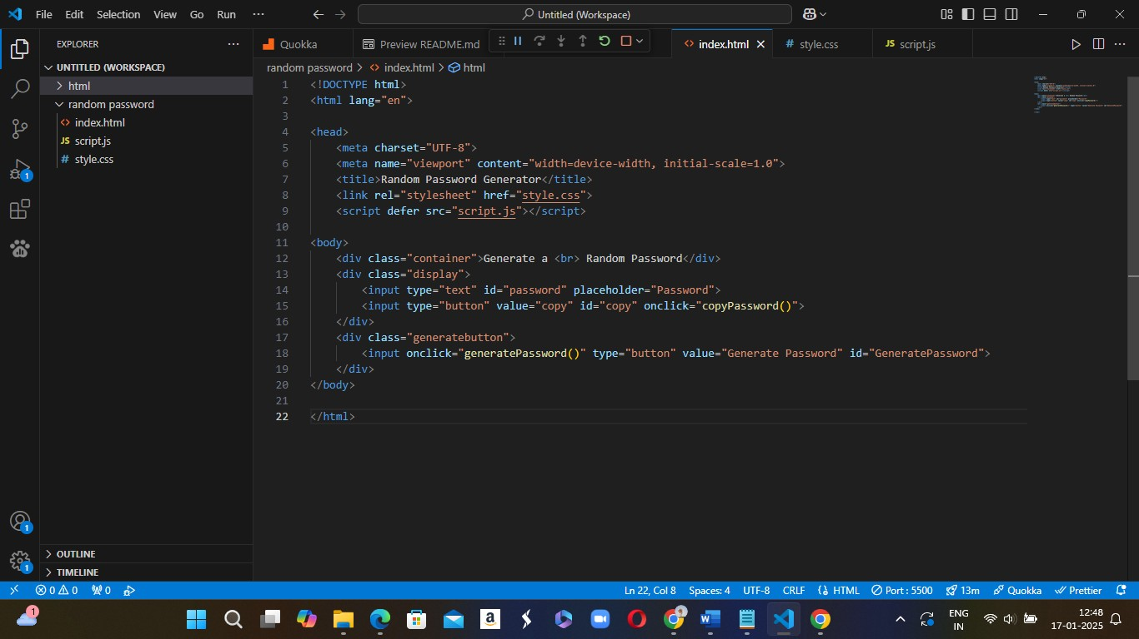

CHAPTER 6

CSS DESCRIPTION AND SOURCE CODE
CSS (Cascading Style Sheets) is used to control the layout, design, and appearance of HTML elements on a web page. For this Random Password Generator project, CSS will be used to style the components and create a visually appealing, user-friendly interface.
- General Layout & Structure
CSS will be used to set the overall layout of the page, including alignment and positioning of elements. The goal is to ensure the app looks clean, centered, and responsive across devices.
  - Container for Centering Content:
    - We use a container class to center all elements on the page, which can be achieved with flexbox or grid.
    - display: flex; and justify-content: center; ensure that the content inside the container is horizontally centered. o align-items: center; ensures vertical centering.
    - min-height: 100vh; (viewport height) makes sure the container stretches to fill the entire height of the screen.

- Styling Input Fields (Password and Length)
The password input field and length input field need to be styled to ensure they are visually appealing, easy to interact with, and appropriately sized.
  - Password Input Field (#password):
The password field should be wide enough to display a password and visually distinct from other elements. Adding padding, borders, and background color helps improve usability.
- Color Scheme
The color scheme should be simple, modern, and easy to read. A clean and minimalistic approach often works best for a password generator.
  - Background Colors:
The background of the page and input fields should be light, with contrast to the text for readability.
The CSS for the Random Password Generator project will focus on a clean, modern, and responsive layout. The styles will ensure that the page is visually appealing, easy to interact with, and functional across different screen sizes. This approach provides a solid foundation for further refinement, customization, and feature additions.
SOURCE CODE:
body{
background-color: rgb(93, 153, 213); margin-left: 100px; margin-top: 150px;
}
.container{
color: rgb(10, 28, 61); font-size: 50px;
font-family:Arial, Helvetica, sans-serif ;
}
#password{
/* color: rgb(165, 178, 202); */ font-size: 30px; margin-top: 30px; border-radius: 5px;

padding: 15px;

}
#copy{ /* margin-top: 30px; */ font-size: 38px; cursor: pointer; padding: 10px; border-radius: 5px;
}
#GeneratePassword{ padding: 10px;; margin-top: 10px; font-size: 20px; cursor: pointer; border-radius: 10px;

}

#GeneratePassword:hover{ background-color: rgb(17, 39, 80); color: rgb(255, 255, 255); border-radius: 10px;
}
#copy:hover{ background-color: rgb(17, 39, 80); color: rgb(255, 255, 255); border-radius: 10px;

}

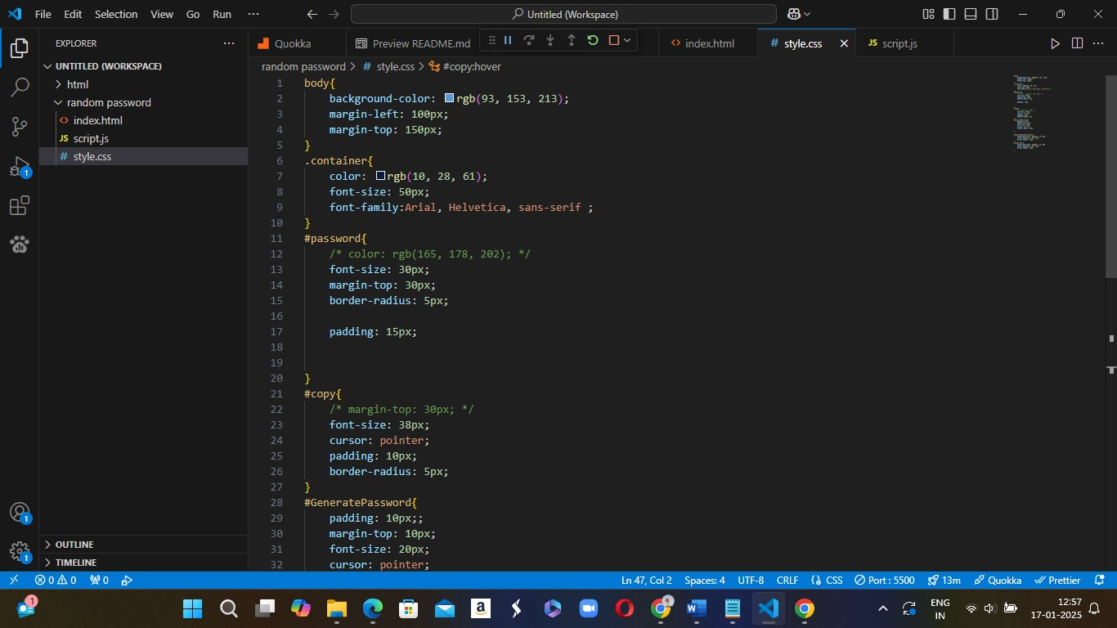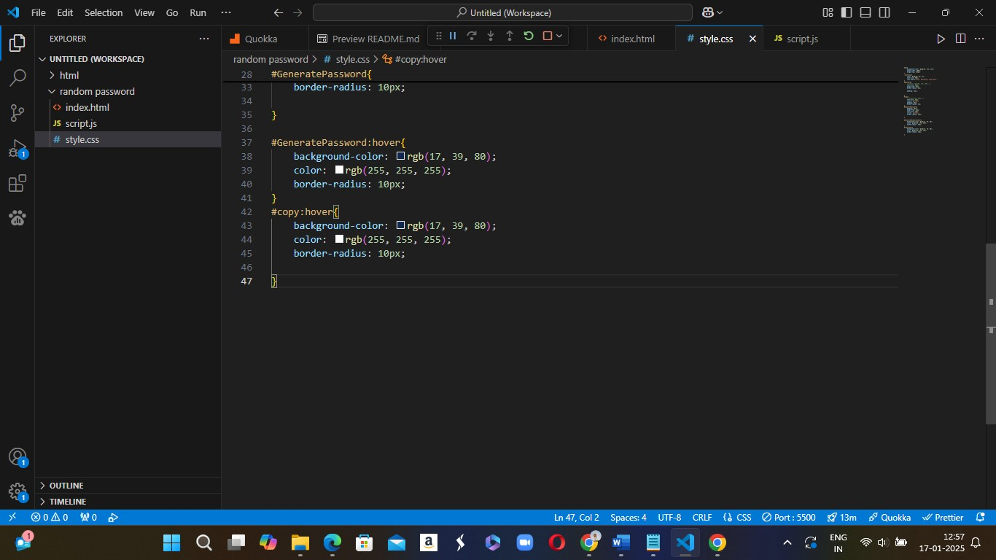

CHAPTER 7

JAVASCRIPT DESCRIPTION AND SOURCE CODE
JavaScript is used to add interactivity and dynamic behavior to the Random Password Generator web application. It handles the logic for generating a random password, copying the password to the clipboard, and ensuring that user preferences (such as length and character types) are respected.
- Defining the Password Generation Logic
The primary functionality of this project is to generate a random password based on user inputs, including:
  - Password length
  - Character types (uppercase letters, lowercase letters, numbers, and symbols) Key Steps:
  - Character Sets: JavaScript defines the character sets for uppercase, lowercase, numbers, and symbols. These sets will be combined based on user preferences.
  - Random Selection: The JavaScript logic will randomly pick characters from the selected sets to form a password of the required length.
- Copy Password to Clipboard
Another core feature of the app is allowing users to easily copy the generated password to their clipboard. This functionality is triggered by clicking the "Copy" button.
Key Steps:
  - The copyPassword() function will use the Clipboard API to copy the password to the clipboard.
  - A simple alert or notification can be shown to let the user know the password was copied successfully.
- Handling User Input and Preferences
The app allows users to customize the password generation by specifying:
  - Password length (e.g., a slider or number input).
  - Character types (checkboxes for uppercase, lowercase, numbers, symbols).
JavaScript will read the values of these inputs and build the password accordingly. The values can be accessed using document.getElementById() for input fields and checkboxes.
- Error Handling and User Feedback
JavaScript can provide error handling to ensure the user selects at least one character type (uppercase, lowercase, numbers, symbols) before generating the password.
The JavaScript for this project handles:
  - Password generation based on user preferences (length and character types).
  - Copying the password to the clipboard for easy use.
  - Handling errors and providing feedback to users when no valid options are selected.
By integrating JavaScript with HTML and CSS, this project creates an interactive and user-friendly random password generator.
SOURCE CODE: const passwordBox = document.getElementById("password"); const length = 16;
const upperCase = "QWERTYUIOPASDFGHJKLZXCVBNM"; const lowerCase = "qwertyuiopasdfghjklzxcvbnm" const number = "1234567890";
const symbol = "!@#$%^&*()_+~`|}{[]\:;?><,./-="; const allChar = upperCase + lowerCase + number + symbol;

function generatePassword() { let password = "";

// let passwords = password.length;
password += upperCase[Math.floor(Math.random() * upperCase.length)]; password += lowerCase[Math.floor(Math.random() * lowerCase.length)]; password += number[Math.floor(Math.random() * number.length)]; password += symbol[Math.floor(Math.random() * symbol.length)];

// get the password until 12 digits

while (length > password.length) {
password += allChar[Math.floor(Math.random() * allChar.length)];

}
passwordBox.value = password;

}

function copyPassword() {
passwordBox.select(); // select the text inside the password box // document.execCommand('Copy'); // copy it to clipboard passwordBox.execCommand("copy") alert("Copied to clipboard!");
}

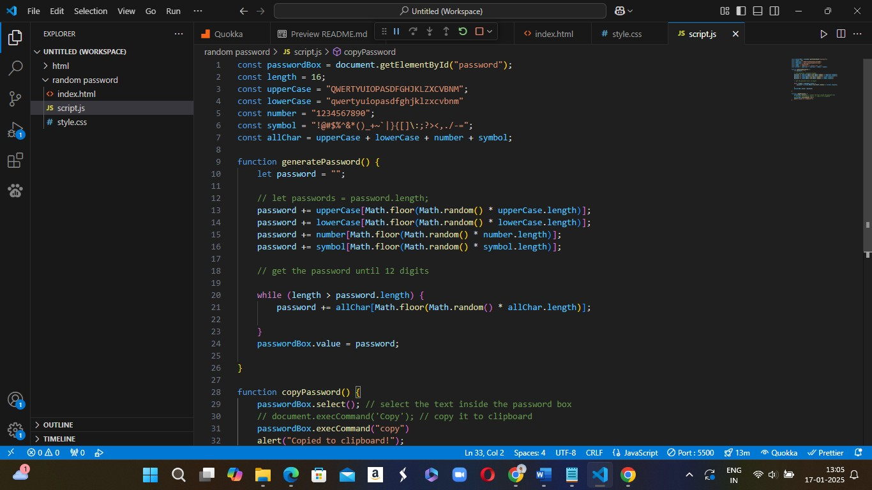

CHAPTER 8

OUTPUT OF THE RANDOM PASSWORD GENERATOR
BEFORE GENERATING A PASSWORD:

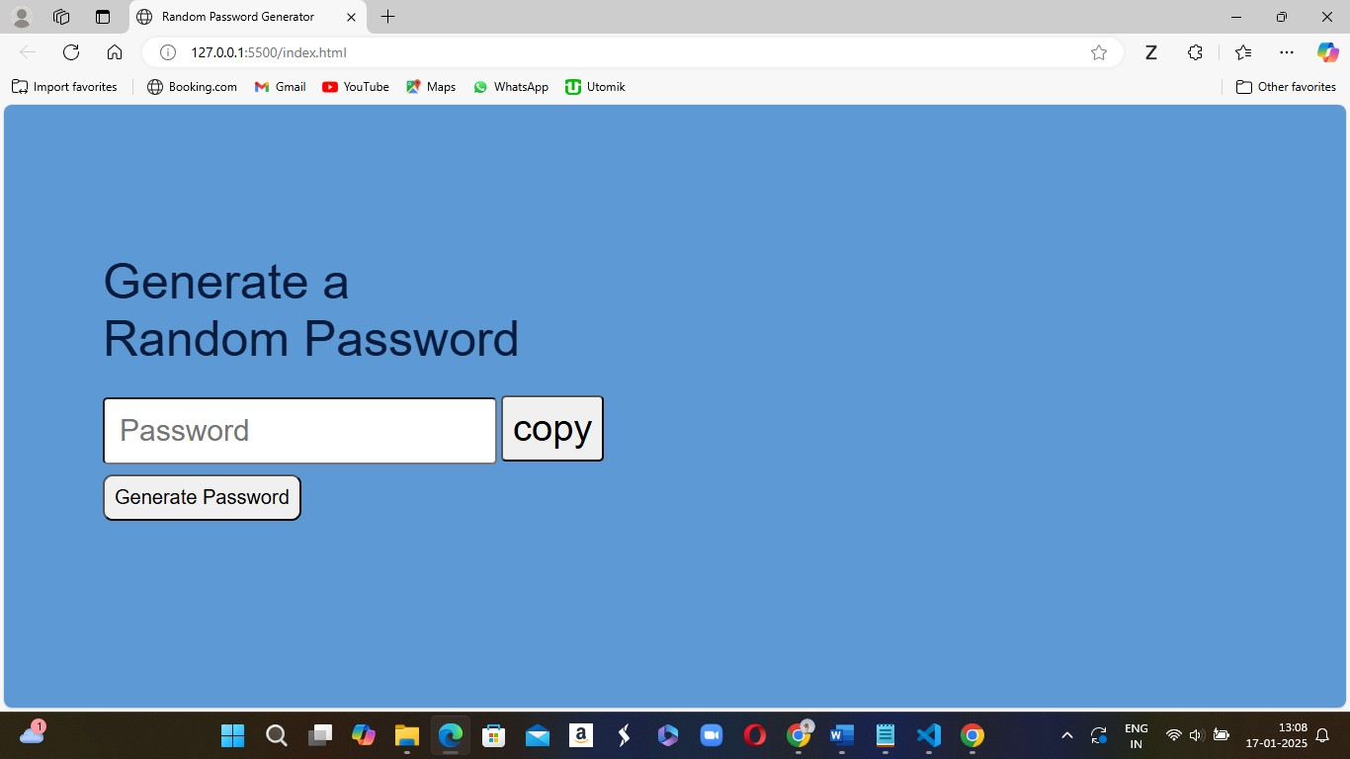

AFTER GENERATING A RANDOM PASSWORD:

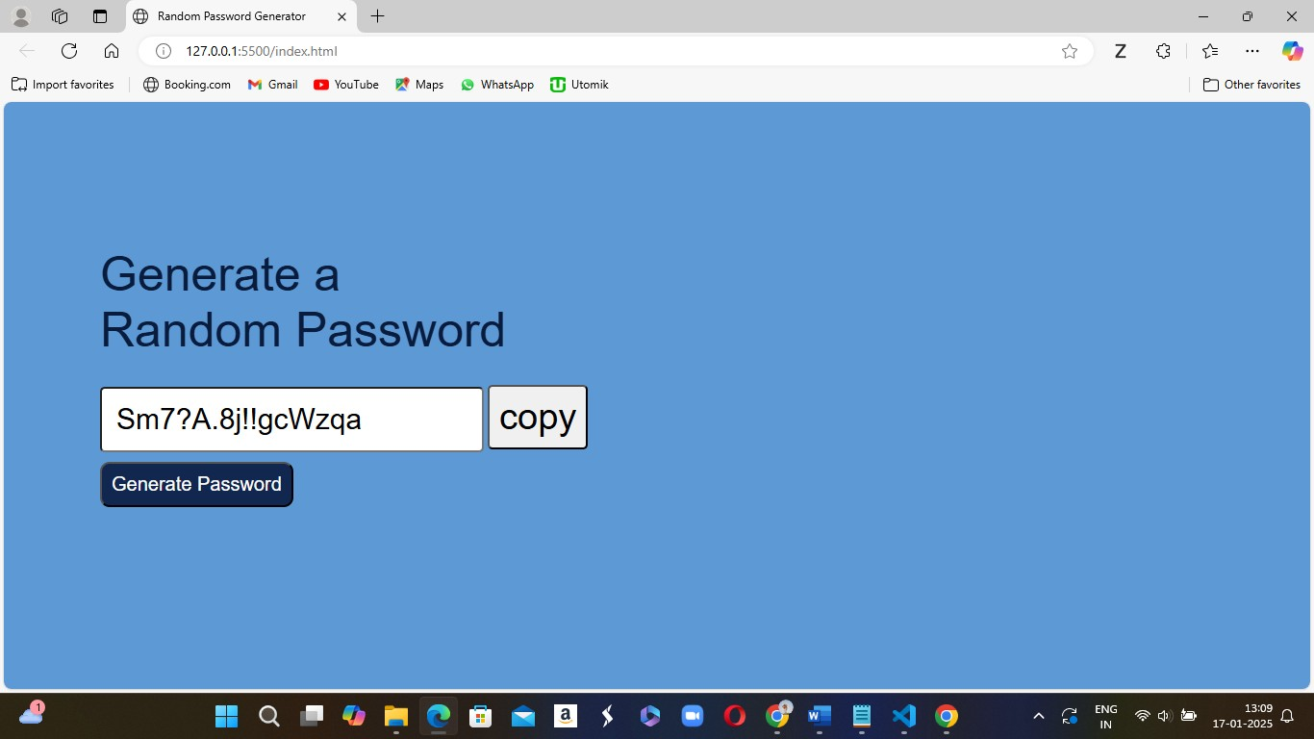

COPYING THE GENERATED PASSWORD:
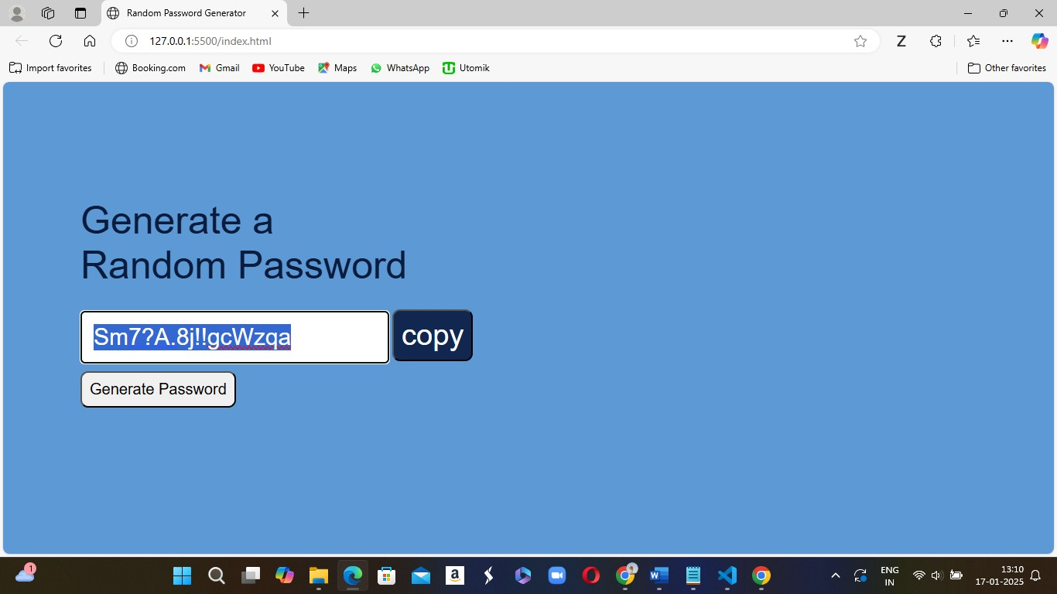
THE GENERATED PASSWORD IS : Sm7?A.8j!!gcWzqa
CHAPTER 9

CONCLUSION
The Random Password Generator project is a practical and essential tool that helps users generate secure, random passwords, ensuring better security practices in web applications. With a growing need for robust security measures, especially as cyber threats continue to evolve, this tool offers an easy and reliable way to create strong passwords. Here's a closer look at the key takeaways and future improvements for this project:
Key Features and Benefits:
- Enhanced Security: The generator ensures that passwords are not only random but also meet common security standards by incorporating a mix of character types—uppercase letters, lowercase letters, numbers, and special characters. This results in complex passwords that are more resistant to brute-force attacks.
- User-Friendly Interface: The project is designed with a simple and intuitive interface, allowing even non-technical users to generate strong passwords with ease. By clicking a button, users can instantly generate a secure password, which is displayed in an input field for easy copying.
- Customizability: The ability to select different character sets (uppercase, lowercase, numbers, symbols) allows users to tailor the complexity of their password according to their security needs. This feature offers flexibility in creating passwords for different use cases, whether for highsecurity accounts or everyday logins.
- Clipboard Integration: With a built-in copy to clipboard feature, users can easily store and use the generated password without having to manually type it out. This enhances convenience and efficiency, reducing the chances of making errors when entering the password.
Learning and Development:
- JavaScript for Dynamic Interaction: The project leverages JavaScript for dynamic password generation, showcasing how to use randomization techniques and handle user input. It demonstrates practical applications of working with arrays, strings, and user events.
- CSS and HTML for Clean UI: The project is also a great example of how HTML and CSS can be used to create an aesthetically pleasing and functional UI. The user interface is simple yet effective, focusing on the main goal of delivering a seamless password generation experience.
Potential Areas for Improvement and Future Enhancements:
- Length Customization: While the password length is currently set to 16 characters, providing a customizable length option could be valuable. Allowing users to set their preferred password length (e.g., a slider or input field) would provide even more flexibility.
- Password Strength Indicator: Incorporating a password strength indicator could further enhance the user experience. This could provide users with immediate feedback on the strength of their generated password, helping them choose even more secure passwords based on length and character variety.
- Clipboard API Usage: As mentioned earlier, the current use of execCommand() is deprecated in modern browsers. The project can be enhanced by implementing the more reliable Clipboard API, ensuring compatibility with the latest browsers and improving overall performance.
- Advanced Features: Adding features like the ability to exclude certain characters (e.g., avoiding confusing characters like l and 1) or enabling passphrase generation could appeal to different user needs. Additionally, offering an option to generate passwords that adhere to specific security policies (such as password rules for websites) would add value to the tool.
Conclusion:
This Random Password Generator project is not only a great introduction to working with JavaScript, HTML, and CSS but also a valuable tool in enhancing password security. It highlights essential principles like randomization, user interactivity, and usability in web development, making it a practical addition to any developer’s portfolio.
By allowing users to easily create strong, random passwords and providing a user-friendly experience, this project demonstrates the importance of security in today's digital world. Future enhancements will further improve the tool, making it more customizable, robust, and in line with modern web standards.
In conclusion, this project offers both an opportunity for hands-on learning in web development and a practical solution for improving online security. Whether for personal use or as part of a larger application, it serves as a solid foundation for anyone interested in creating secure, user-friendly web tools.

